
Preparing for a Retell
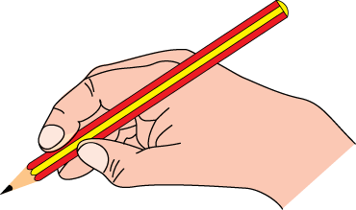
1. Read a really good story.

2. List or draw the most important events from
the story.

3. Read the story again to be sure that you have gotten
the most important ideas.
4. Plan for any props that will make your
retell interesting to an audience.
5. Practice
- inside your head
Be sure to remember:
- Characters
- Setting
- Events
- Your Opinion!
- to a partner
- in front of a mirror

- by talking into a tape recorder
6. Tell your story to an
audience.

